AAI Log Converter

AARP provided a 24-hour snapshot of service call logs.

186 files

Files are in .txt format

956 MB of Data

30 partners

78 services

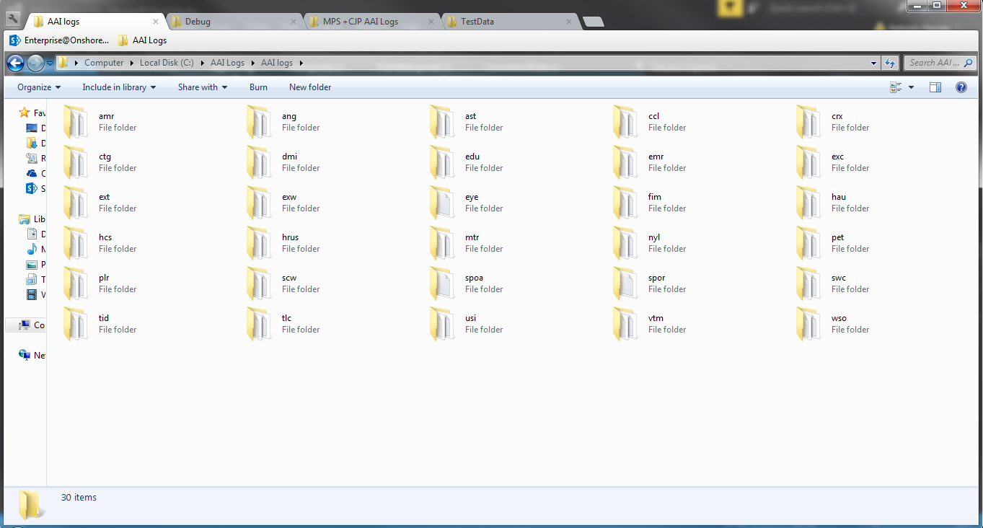

Figure 1

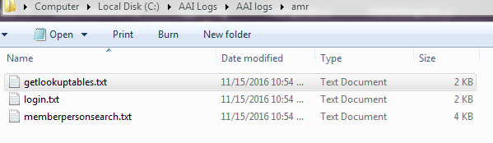

Figure 2

Figure 3-A

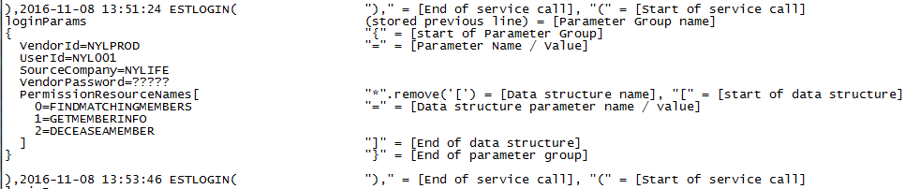

Figure 3-B

Requirements:

* Call log:

1. One file with all of the timestamps and corresponding partner name and web service
2. Time stamps need to be in military time(24 hour clock) and in Pacific Time
3. Columns for Service Name, Date, Time, Partner ID

* [service]_Data

1. Combine all partner data in one file for each web service
2. Each parameter shall be its own column
3. Add columns for Time, Date, PartnerID
4. Each row is a single service call
5. Time stamps need to be in military time(24 hour clock) and in Pacific Time

* [service]_Usage

1. Combine all partner data in one file for each web service
2. Each parameter shall be its own Row
3. In usage statistics have two separate columns for number of times a field is null and number of times a field is empty.
4. Columns for Parameter Name, Times Called, Times Null, Times Empty, Usage Percentage
5. Parameter Name = the name of the parameter passed to the service from each partner
6. Times called = the number of times the parameter was passed to the service from each partner
7. Times Null = the number of times the parameter was passed with a value of “null”
8. Times Empty = the number of times the parameter was passed with an empty value or “”
9. Usage Percentage = format - ###%  
   (((timesCalled - (timesNull + timesEmpty)) / timesCalled) * 100)

* Additional Info:

1. There are 30 folders in the AAI Logs Folder, the folder names correspond to the ParterIDs and at this time is the only reliable source of PartnerIDs. *see: figure 1*
2. Timestamps are displayed as Eastern Standard Time in the Logs. *See: figure 3-A - Line 12, 24, 36*
3. The files located in the 30 partner folders are named as the service name. *see: figure 2*
4. Service calls are expected to be in a particular format; this format is provided by the Logs and is ether not accessible or not previously documented/ provided. In order to extract data from a service call, custom rules are applied to each line of the file. *see: figure 3-B*